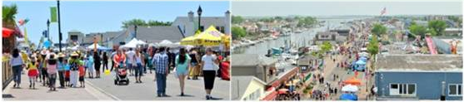
Coming Soon!
The 2021 Annual Freeport Nautical Festival

*Children’s rides/games, food, music, vendors, & more!

(Woodcleft Avenue, Freeport ~ Along the Famous Nautical Mile!)

Saturday, June 12th
10am – 6pm
Fee: $100.00 (10’X10’ Spot)
Vendors Wanted!

Send an email to vdinielli@freeportny.gov
for information or for an event application.

