A Very Festive Evening in the
Village of Freeport
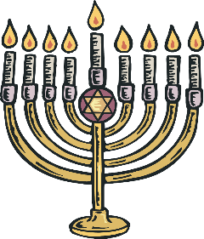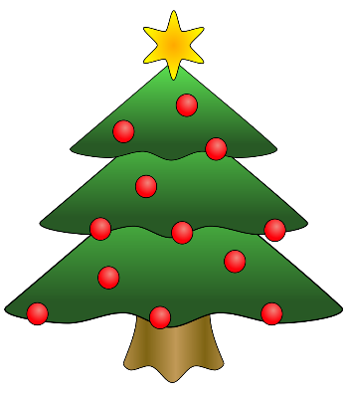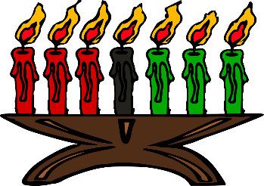

Saturday, December 4, 2021
*Holiday Tree and Candle Lighting*
With the help of Santa, Mayor Robert Kennedy will kick-off
this Holiday Season at the following locations:

5:30pm - Village Triangle at Sunrise Highway & Church Street
6:00pm - FPT Recreation Center Outdoor Front Lawn Tree
6:30pm - The Esplanade on Woodcleft Avenue
Hot Chocolate will be served.
(Adjacent to the Riverhouse Grill)

Annual Freeport Boat Parade
Sponsored by the NMMA, festive decorated boats will parade
on the Woodcleft Avenue Canal. Participating restaurants & businesses will offer evening specials.

7:00pm - Holiday Boat Parade will begin!

